Deleting / Removing and Correcting Sacramental Register Records

Deleting Sacramental Register Entries
A [Delete] button is available on all Sacramental (SR) register records including Sacraments Administered Elsewhere. This allows parishes to remove duplicate entries or records accidentally logged in the wrong register.

Important Note on Deletions:
- Irreversible Action: Deleting a record is permanent and cannot be undone.
- Verification Required: Only delete a record if you are absolutely certain it is incorrect or a duplicate of an existing entry.

When you click Delete, a warning message will appear to confirm that the selected Sacramental record will be permanently removed. Enter Delete in the text box and select the Delete button to permanently remove the record.

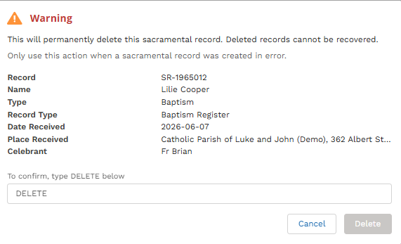

The [Delete] button is normally located in the top right hand corner of the Sacramental Register record. For Confirmation records, use the dropdown arrow next to the [Print] function to locate the [Delete] option.

Correcting Parish Classification vs. Deletion
- Important Rule: If a sacrament was administered in your parish but incorrectly classified in PACEM as Administered by another Parish, do not delete the record unless a duplicate entry already exists. Deletion completely erases the historical record.

- How to Correct: Critical Pre-Check (Duplicate Check): Before changing an "Administered elsewhere" record to a local home parish entry, you must check the register to ensure a local home parish entry does not already exist. If a duplicate local entry exists, changing the external record will cause data conflicts, and the system may prevent the record from linking properly to the contact record.

  - Self-Service Update: If no duplicate local record exists and the sacrament genuinely occurred at your parish, you do not need to delete it. You can change the classification directly using the procedures outlined in the Changing a sacramental entry guide.

  - Important System Limitation: Note that this direction only works one way. Users can update an "administered elsewhere" record to a local home parish entry. However, a local home parish entry cannot be changed to an administered elsewhere record by a user (see the PACEM team deletion rules below for the reverse scenario).

Important Notes: Sacramental register records can be deleted in the following cases:

- Deletion should only be used if the Sacramental record was created in error (eg duplicate entries either for home parish records or duplicates of sacraments administered at a different parish). Do not use deletion to fix administrative classification errors for sacraments that genuinely occurred at your parish.

- When NOT to Delete: Do not delete if a local sacrament was mistakenly saved as Administered by another Parish. Because the system allows you to upgrade an external record to a local home parish entry, you should update the record yourself rather than requesting a deletion.

Deletion Confirmation Sacramental Register Entries
The Print Certificate menu button includes a dropdown button with the following options:

- View Linked Baptism Record (if one exists)
- Delete Confirmation Record

Important Notes: Sacramental register records can be deleted in the following cases:
- Deletion should only be used if the Confirmation record was created in error.

Sacrament Record Deletion (Double-Registrations) - Baptisms, First Eucharists, Funerals, Marriages
If a sacrament record has been registered twice in error, creating a duplicate entry (one linked and one unlinked to a contact record or two unlinked standalone sacramental records), you can remove the duplicate:

- Action: Open the duplicate entry, navigate to the top right-hand corner, and click the [Delete] button.

